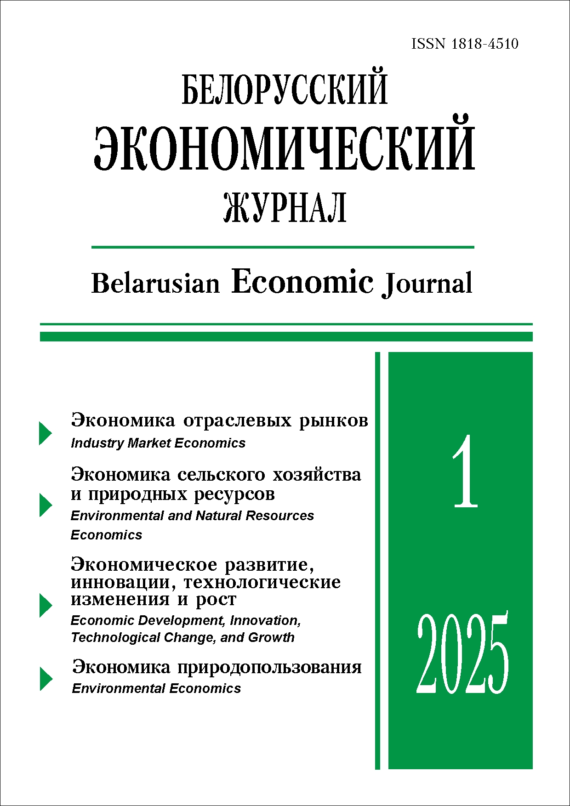 | ISSN 1818-4510  Belarusian  Economic Journal  Quarterly scientific and practical journal  Published since 1997  No 1 ● 2025
RESUME

BALANCED SECTORAL DEVELOPMENT:
A CASE STUDY OF THE REPUBLIC OF BELARUS
Mikhail Kovalev¹ (https://orcid.org/0000-0001-9009-6752),
Anna Koroleva¹ (https://orcid.org/0000-0003-3993-5607)
¹ Belarusian State University (Minsk, Belarus).
Corresponding author: Mikhail Kovalev (kovalev@bsu.by).
ABSTRACT. The article considers the concept of balanced economic development and proposes indicators and measures for analysing the balanced development of industries. It analyses the development of the four most important industries for the country – agriculture, manufacturing, transport, and information and communication. The periods of their balanced, conditionally balanced, and unbalanced development are defined. Conclusions are drawn regarding the prospects for the development of the selected industries.
KEYWORDS: balanced growth, sectoral development, Neumann development highway, Dorfman–Samuelson–Solow theory.
JEL-code: L60, L86, L90.
DOI: 10.46782/1818-4510-2025-1-4-15
Received 17.02.2025
In citation: Kovalev M., Koroleva A. 2025. Balanced Sectoral Development: A Case Study of the Republic of Belarus. Belorusskiy ekonomicheskiy zhurnal. No 1. PP. 4–15. DOI: 10.46782/1818-4510-2025-1-4-15 (In Russ.)

COORDINATED ECONOMIC MODEL OF THE UNION STATE: NATIONAL PRIORITIES FOR FOOD SECURITY
IN BELARUS
Natallia Kireyenka¹ (https://orcid.org/0000-0001-9781-5780)
¹ Belarusian State Agrarian Technical University (Minsk, Belarus).
Corresponding author: Natallia Kireyenka (natallia_kireenko@mail.ru).
ABSTRACT. The article identifies the characteristic features of national legislation in the member states of the Union State regarding food security. It analyzes the main production and economic indicators of agriculture in the Republic of Belarus and determines the country's contribution to the food supply of the common market within the integration association. The strategic directions for forming a coordinated economic model of the Union State are substantiated, considering Belarus's national priorities in ensuring food security.
KEYWORDS: economic model, food security, integration association, national priority, potential, interregional cooperation, agricultural sector.
JEL-code: F47, Q01, Q13, Q17, Q18.
DOI: 10.46782/1818-4510-2025-1-16-30
Received 10.01.2025
In citation: Kireyenka N. 2025. Coordinated Economic Model of the Union State: National Priorities for Food Security in Belarus. Belorusskiy ekonomicheskiy zhurnal. No 1. PP. 16–30. DOI: 10.46782/1818-4510-2025-1-16-30 (In Russ.)

INCLUSIVITY OF INSTITUTIONS AS A FACTOR
OF ECONOMIC DEVELOPMENT ACCELERATION
Victor Vorobiev¹ (https://orcid.org/0000-0001-8285-7304),
Tatiana Maibarada¹ (https://orcid.org/0000-0002-9589-8620)
¹ Belarusian State Economic University (Minsk, Belarus).
Corresponding author: Victor Vorobiev (vorobiev_v@bseu.by).
ABSTRACT. This paper presents the contribution of D. Acemoglu, S. Johnson, and J. Robinson to uncovering the fundamental role of different types of political and economic institutions in explaining large and relatively persistent differences in economic development across countries. Combining empirical, quasi-experimental, and game-based approaches, the laureates show which political forces, incentives, and mechanisms determine the prosperity of some countries and the poverty of others. Their theoretical research reveals the complexity of reforming extractive institutions and the processes that can facilitate this.
KEYWORDS: political power, political institutions, economic institutions, extractive institutions, inclusive institutions, economic development, historical persistence, institutional stability, institutional reforms, Coase’s political theorem, social conflict theory.
JEL-code: B00, В52, D02, D72, N01, O10, P14.
DOI: 10.46782/1818-4510-2025-1-31-52
Received 16.11.2024
In citation: Vorobiev V., Maibarada T. 2025. inclusivity of institutions as a factor of economic development accelerationt. Belorusskiy ekonomicheskiy zhurnal. No 1. PP. 31–52. DOI: 10.46782/1818-4510-2025-1-31-52 (In Russ.)

THEORETICAL AND METHODOLOGICAL FOUNDATIONS OF THE ECONOMIC MODEL WITH CYCLIC USE OF SECONDARY MATERIAL RESOURCES
Natallia Leanovich¹ (https://orcid.org/0000-0002-0315-1918)
¹ Brest State Technical University (Brest, Belarus).
Corresponding author: Leanovich Natallia (nnleonovich@g.bstu.by).
ABSTRACT. The article examines the theoretical and methodological foundations of a resource-saving model of the closed-cycle economy. It studies national statistics from the Republic of Belarus that reflect the volumes of solid municipal waste and production waste generation. The fundamental components of the economic system functioning with cyclic use of secondary material resources are highlighted.
KEYWORDS: circular economy, resource saving, secondary material resources.
JEL-code: O44.
DOI: 10.46782/1818-4510-2025-1-53-61
Received 10.01.2025
In citation: Leanovich N. 2025. Theoretical and methodological foundations of the economic model with cyclic use of secondary material resources. Belorusskiy ekonomicheskiy zhurnal. No 1. PP. 53–61. DOI: 10.46782/1818-4510-2025-1-53-61 (In Russ.)

Signs of an enterprise crisis under the influence of unfavorable external shocks
Aliaksei Bykau¹ (https://orcid.org/0000-0003-2005-9061),
Sergey Hurynovich1 ¹https://orcid.org/0009-0000-2983-9641),
Nataliya Khaustovich¹ (https://orcid.org/0009-0007-8649-6412)
¹ Belarusian State Economic University (Minsk, Belarus).
Corresponding author: Aliaksei Bykau (aliaksei.bykau@yandex.ru).
ABSTRACT. In terms of their origin, modern economic crises are very different from the transitional crisis of the 1990s, during which the theory of anti-crisis management was developed. Modern crises are mostly the result of external shocks, i.e. events that significantly and negatively affect the economy, the source of which is outside the national economic system and is not caused by internal contradictions in the sphere of commodity or money circulation. The paper analyzes the degree of influence of the pandemic crisis of 2020 and the sanctions pressure of 2022 on the Belarusian economy. From a wide range of statistical indicators, an indicator was selected that most fully reflects the impact of these crises on the business sector of the Belarusian economy. Approaches to improving anti-crisis management in the context of the impact of external shocks on the Belarusian economy are proposed.
KEYWORDS: anti-crisis management, financial diagnostics, external shocks, sanctions, Belarusian economy.
JEL-code: G33, H12.
DOI: 10.46782/1818-4510-2025-1-62-77
Received 21.01.2025
In citation: Bykau A., Hurynovich S., Khaustovich N. 2025. Signs of an enterprise crisis under the influence of unfavorable external shocks. Belorusskiy ekonomicheskiy zhurnal. No 1. PP. 62–77 DOI: 10.46782/1818-4510-2025-1-62-77 (In Russ.)

Internal Environment of a Healthcare Institution from the Perspective of Analyzing the Effectiveness of Its Institutional Functions
Yildirim Selami¹ (https://orcid.org/0000-0002-7059-8365),
Elena Malashenko² (https://orcid.org/0000-0003-4472-9824)
¹ Baku State University of Economics (Baku, Azerbaijan),
² Belarusian State Economic University (Minsk, Belarus).
Corresponding author: Elena Malashenko (malashenko@bseu.by).
ABSTRACT. The article analyses the internal environment of medical institutions to enhance the efficiency of institutional functions. Key factors influencing the internal environment are identified. The authors examine existing theoretical models, and provide a comparative analysis of various methodologies for assessing the internal environment. The functional subsystems affecting the efficiency of medical institutions are also studied. The study identifies the main criteria of the internal environment and considers their interrelationships with external factors.
The results confirm the importance of using an integrated approach that includes the analysis of functional subsystems, resource management, and strategic planning. This integrated approach to assessing the internal environment optimises resource utilisation, improves the quality of medical services, and enhances the competitiveness of healthcare institutions.
KEYWORDS: internal environment, healthcare management, performance assessment, institutional functions, strategic planning.
JEL-code: I18, D46.
DOI: 10.46782/1818-4510-2025-1-78-92
Received 17.01.2025
In citation: Selami Y., Malashenko E. 2025. Internal Environment of a Healthcare Institution from the Perspective of Analyzing the Effectiveness of Its Institutional Functions. Belorusskiy ekonomicheskiy zhurnal. No 1. PP. 78–92. DOI: 10.46782/1818-4510-2025-1-78-92 (In Russ.)

ECOLOGICAL EDUCATION IN BELARUS
AS THE BASIS FOR A SUSTAINABLE ECONOMY
Nadezhda Batova¹ (https://orcid.org/0000-0003-3971-4046),
Elena Onufrovich² (https://orcid.org/0000-0003-3971-4046),
¹ The Institute of Economics of the National Academy of Sciences of Belarus (Minsk, Belarus),
2 Republican Center for Ecology and Local History (Minsk, Belarus).
Corresponding author: Nadezhda Batova (nbatava@gmail.com).
ABSTRACT. The article studies global trends in the development of environmental education and the inclusion of the environmental agenda in educational processes through interdisciplinary approaches and digital technologies. It assesses the development of environmental education in Belarus and its role in shaping environmental consciousness among young people. The perception of environmental problems by children and adolescents is investigated, and promising directions for environmental education are considered. The principles, approaches, and models for integrating the environmental and climate agenda into the education system of the Republic of Belarus are substantiated, taking international experience into account.
KEYWORDS: sustainable development, greening of the economy, human resources for sustainable development, ecological education, youth perception of ecology
JEL-code: Q01, Q54, I25, Q56, О13, Р36.
DOI: 10.46782/1818-4510-2025-1-93-105
Received 6.12.2024
In citation: Batova N., Onufrovich E. 2025. ecological education in belarus as the basis for a sustainable economy. Belorusskiy ekonomicheskiy zhurnal. No 1. PP. 93–105 DOI: 10.46782/1818-4510-2025-1-93-105 (In Russ.)

INSTITUTIONAL SUSTAINABILITY AS A KEY ELEMENT
OF SUSTAINABLE DEVELOPMENT: THE NEED
TO RECONSIDER THEORY IN THE CONTEXT
OF NATIONAL STRATEGIES
Olga Balabanovich¹ (https://orcid.org/0000-0001-9780-0108)
¹ Belarusian State Economic University (Minsk, Belarus).
Corresponding author: Balabanovich Olga (balabanovichoa@tut.by).
ABSTRACT. This article explores the genesis of the concept of sustainable development, examining key stages in the formation of the theory and their impact on international agreements. Definitions reflecting the multifaceted nature of this concept are grouped by direction. The critique of the three-component model of sustainable development proposed by the Club of Rome is analyzed. The article emphasizes the necessity of modifying sustainable development theory to align with national priorities. The need to transition from the classical three-component model to a four-component one—incorporating institutional sustainability as the foundation of effective governance – is substantiated. This approach ensures governance system stability and balanced development while considering the realities of the global economy, integration processes, and national interests.
KEYWORDS: sustainable development, national strategy, institutional sustainability, strategic management, economic growth.
JEL-code: Q01, O43, H11, F64, L21.
DOI: 10.46782/1818-4510-2025-1-106-118
Received 21.01.2025
In citation: Balabanovich O. 2025. Hinstitutional Sustainability as a Key Element of Sustainable Development: The Need to Reconsider Theory in the Context of National Strategies. Belorusskiy ekonomicheskiy zhurnal. No 1. PP. 106–118. DOI: 10.46782/1818-4510-2025-1-106-118 (In Russ.)

A MULTIFACETED ANALYSIS OF TEXTUAL EVIDENCE
OF THE EFFECTIVENESS OF GREEN AND LOW-CARBON TRANSPORT DEVELOPMENT
Mikhail K. Zhudro¹,
Jun Li¹,
Xianpenq Wanq²,
Mikhail M. Zhudro³
1 Belarusian National Technical University (Minsk, Belarus),
2 International Institute of Management and Entrepreneurship (Minsk, Belarus),
3 Mogilev State Regional Institute for Education Development (Mogilev, Belarus).
Corresponding author: Mikhail Zhudro (nv_mk@mail.ru).
ABSTRACT. The article employs the Multifaceted Analysis of Textual Evidence (MATE) methodology to conduct a bibliometric analysis of previously published scientific papers on Green Energy Transportation (GET). The fundamental importance of green energy economics in reducing environmental damage is substantiated. Signs of less optimistic prospects for public and scientific recognition of Green Energy Transportation, along with potential difficulties in implementing related business projects, are identified. Given the current lack of a comprehensive review of the accumulated knowledge in the field of research on the effectiveness of Green Energy Transportation, the article argues for the urgency of addressing this gap and substantiates the need for continuous, end-to-end analysis of all variables and motivations of its stakeholders.
KEYWORDS: green energy, transport, research, bibliometric methods, MATE methodology.
JEL-code: I18, D46.
DOI: 10.46782/1818-4510-2025-1-119-127
Received 13.12.2024
In citation: Zhudro1 M.K., Li J., Wanq X, Zhudro M.M.. 2025. A Multifaceted Analysis of Textual Evidence of the Effectiveness of Green and Low-carbon Transport Development. Belorusskiy ekonomicheskiy zhurnal. No 1. PP. 119–127 DOI: 10.46782/1818-4510-2025-1-119-127 (In Russ.)

HELIO-DEPENDENT BEHAVIORAL FACTOR
IN THE FORMATION OF FINANCIAL ACTIVITY CYCLES
Yuliya Sidorenko¹
¹ Belarusian State Economic University (Minsk, Belarus).
Corresponding author: Leanovich Natallia (ms.sidego@mail.ru).
ABSTRACT. The article studies Kondratiev waves, Kuznets swings, Juglar cycles, and century cycles of financial activity in the context of behavioral finance, along with the works of A.L. Chizhevsky. It determines the characteristics of changes in solar activity that can serve as indicators of shifts in the behavior of large populations—leading to changes in the phases of business cycles of varying durations.
KEYWORDS: financial moods, solar activity, Chizhevsky’s heliophysics, Kondratiev cycles, Kuznets swings, Juglar cycles, Schumpeter’s scheme.
JEL-code: G01, G41, F44.
DOI: 10.46782/1818-4510-2025-1-128-137
Received 3.12.2024
In citation: Sidorenko Yu.Yu. 2025. Helio-dependent Behavioral Factor in the Formation of Financial Activity Cycles. Belorusskiy ekonomicheskiy zhurnal. No 1. PP. 128–137. DOI: 10.46782/1818-4510-2025-1-128-137 (In Russ.)

MARKET OF CANINE GOODS AND SERVICES
IN BELARUS: PECULIARITIES AND PROSPECTS
Maxim Nikolsky¹ (https://orcid.org/0009-0004-2025-1509)
¹ Belarusian State University (Minsk, Belarus).
Corresponding author: Maxim Nikolsky (maxnikolsky007@gmail.com).
ABSTRACT. The article characterizes the Belarusian market for canine goods and services. It examines the peculiarities of wholesale and retail trade in these products and assesses the development of canine services in the national market. Additionally, the factors influencing the development of the market for canine goods and services are highlighted.
KEYWORDS: canine goods market, canine services, wholesale and retail trade, product development.
JEL-code: M21, G12, L81, L84.
DOI: 10.46782/1818-4510-2025-1-138-145
Received 25.11.2024
In citation: Nikolsky M.A. 2025. Market of Canine Goods and Services in Belarus: Peculiarities and Prospects. Belorusskiy ekonomicheskiy zhurnal. No 1. PP. 138–145. DOI: 10.46782/1818-4510-2025-1-138-145 (In Russ.)

