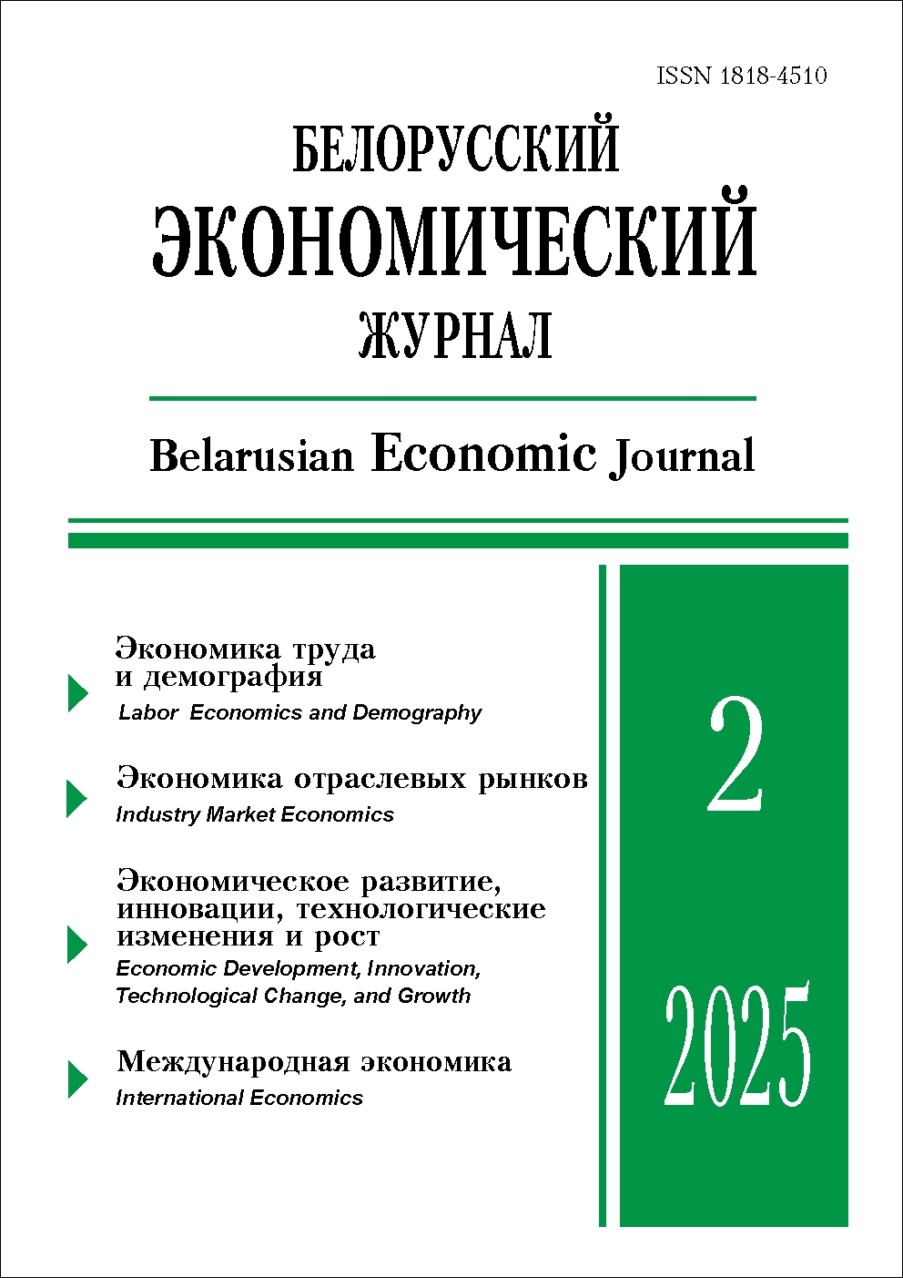 | ISSN 1818-4510  Belarusian  Economic Journal  Quarterly scientific and practical journal  Published since 1997  No 2 ● 2025
RESUME

ACTIVE LONGEVITY AS A RESULT OF THE INDIVIDUAL’S LIFE PATH
Nina Agabekova1 (https://orcid.org/0000-0002-4315-7177),
Evgenia Sharilova1 (https://orcid.org/0000-0002-4862-3624)
1 Belarus State Economic University (Minsk, Belarus).
Corresponding author: Agabekova Nina (agabnin@mail.ru).
ABSTRACT. This article presents methodological support for extending the active longevity policy across all stages of human life. It defines the life path of individuals and identifies various types of life paths within the population of Belarus based on their constituent components. Key indicators of active longevity are established, focusing on aspects such as health, employment, social inclusion, educational opportunities, and family involvement. A methodological approach for statistically evaluating the relationship between life path types and active longevity indicators is developed, accompanied by recommendations for enhancing state policy in line with the National Strategy «Active Longevity – 2030». This work is part of the International Technical Assistance Project aimed at strengthening the scientific and educational capacity of Belarus regarding demographic data use for achieving Sustainable Development Goals, financed by the Government of the Russian Federation and implemented by the UN Population Fund (UNFPA) in collaboration with the Ministry of Labour and Social Protection of Belarus.
KEYWORDS: active longevity, life path, indicators, statistical evaluation, state policy.
JEL-code: J14, A14, C46.
DOI: 10.46782/1818-4510-2025-2-4-16
Received 19.05.2025
In citation: Agabekova N., Sharilova E. 2025. Active longevity as a result of the individual’s life path. Belorusskiy ekonomicheskiy zhurnal. No 2. PP. 4–16 DOI: 10.46782/1818-4510-2025-2-4-16 (In Russ.)

THEORETICAL AND METHODOLOGICAL ASPECTS
OF THE FORMATION OF THE DIGITAL ECOSYSTEM
OF THE LABOR MARKET IN BELARUS
Аlena Vankevich1 (https://orcid.org/0000-0001-8064-8250),
Iryna Kalinouskaya1 (https://orcid.org/0000-0002-6622-2875)
1 Vitebsk State Technological University (Vitebsk, Belarus).
Corresponding author: Alena Vankevich (vankevich_ev@tut.by).
ABSTRACT. The article focuses on the theoretical and methodological aspects of forming the digital ecosystem of the labour market in the Republic of Belarus. The purpose of the study is to identify the directions for developing this digital ecosystem and its methodological support as an effective form of information and analytical assistance for decision-making by labour market participants in the context of digitalisation.
The essence of the digital ecosystem of the labour market is defined as a partnership among interested participants organised on a single national digital platform that consolidates information resources about the labour market, including those found on online sources. The author proposes a methodology for analysing the labour market in the Republic of Belarus based on online sources. Testing this methodology has allowed the formation of a database on vacancies, resumes, and skills. It also enables the calculation of labour market conditions in terms of skills, comparison of the demand for skills from employers with the “reserve” available among the population, and identification of any excess or deficit.
Additionally, the article identifies the institutional, methodological, informational, and organisational barriers and limitations in forming the digital ecosystem of the labour market and its analytical capabilities.
Keywords: labour market, digital ecosystem, skills, big data on the labour market, labour market conditions.
JEL-code: J24, O33.
DOI: 10.46782/1818-4510-2025-2-17-32
Received 15.04.2025
In citation: Vankevich A., Kalinouskaya I. 2025. theoretical and methodological aspects of the formation of the digital ecosystem of the labor market in belarus. Belorusskiy ekonomicheskiy zhurnal. No 2. PP. 17–32. DOI: 10.46782/1818-4510-2025-2-17-32 (In Russ.)

CONTRIBUTION OF SMALL AND MEDIUM ENTERPRISES
TO THE ECONOMIC DYNAMICS OF CHINA AND BELARUS
Alexander Gotovsky1 (https://orcid.org/0000-0002-5470-9010),
Scopus Author ID: 57212407661

1 The Institute of Economics of the National Academy of Sciences of Belarus (Minsk, Belarus).
Corresponding author: Alexander Gotovsky (agotovsky@tut.by).
ABSTRACT. The widely held view is that large organisations are the main drivers of economic growth in China and Belarus. However, small and medium-sized enterprises (SMEs) play a significant social role in providing employment and serve as a «cradle» for future «unicorns». Verifying the thesis about the role of enterprises in economic growth based on their size is not straightforward. Statistics on small and medium organisations are often specific and fragmented on many issues, and this is even more pronounced in the People’s Republic of China. This article presents an analysis of the contribution of small and medium enterprises to the economic dynamics of China and Belarus, based on a summary of official data.
Keywords: small and medium enterprises, economic growth, structural decomposition analysis.
JEL-code: L16, L50.
DOI: 10.46782/1818-4510-2025-2-33-46
Received 21.02.2025
In citation: Gotovsky A.V. 2025. Contribution of Small and Medium Enterprises to the Economic Dynamics of China and Belarus. Belorusskiy ekonomicheskiy zhurnal. No 2. PP. 33–46. DOI: 10.46782/1818-4510-2025-2-33-46 (In Russ.)

THEORY OF INDUSTRY CYCLES AND EVOLUTION
OF VALUE CHAINS IN FERROUS METALLURGY:
FROM LOCAL TO GLOCAL SYSTEMS
Oleg Navarro1 (https://orcid.org/0009-0006-8145-1998)
1 PK Stalprokat (Moscow, Russia).
Corresponding author: Oleg Navarro (oleg_navarro@mail.ru).
ABSTRACT. The article analyses the interrelationship between the economic cycles of varying periodicity and the evolution of value chains (VC) in the ferrous metallurgy industry. The possibility of transitioning from local to glocal systems, combining global integration and local adaptation, is considered. The patterns of influence of ESG standards, digital transformation (Industry 4.0), and geopolitical changes on the formation of new organisational forms in the industry are identified. The possibility of applying the results to develop sustainable development strategies for metallurgical companies, optimise investment decisions, and reduce risks in volatile markets is explored. The prospects for the development of green metallurgy are analysed, including in the field of hydrogen technologies, direct iron reduction methods, and carbon capture.
KEYWORDS: ferrous metallurgy, value chain, economic cycles, glocalisation, transaction costs, global value chains.
JEL-code: D23, F23, L22, L61.
DOI: 10.46782/1818-4510-2025-2-47-66
Received 4.04.2025
In citation: Navarro O. 2025. Theory of Industry Cycles and Evolution of Value Chains in Ferrous Metallurgy: From Local to Glocal Systems. Belorusskiy ekonomicheskiy zhurnal. No 2. PP. 47–66. DOI: 10.46782/1818-4510-2025-2-47-66 (In Russ.)

ARTIFICIAL INTELLIGENCE IN THE CONTEXT
OF HUMAN CAPITAL DYNAMICS
Alexander Bondar 1 (https://orcid.org/0000-0003-2610-9285)
Kseniya Sharova 2 (https://orcid.org/0000-0002-1286-4522)

1 Belarusian State Economic University (Minsk, Belarus),
2 Baranavichy State University (Baranavichy, Belarus).
Corresponding author: Kseniya Sharova (kseniya86@mail.ru).
ABSTRACT. This article examines the interaction between human capital and artificial intelligence, highlighting its role in driving the innovative development of the economy. It discusses how technologies based on neural networks lead to the creation of new products and services, enhance the quality of solutions, and improve the competitiveness of enterprises. The analysis focuses on the concept of human capital within the context of advancing artificial intelligence technologies and explores the transformation of human capital influenced by these developments. The article concludes with scientifically grounded insights and practical recommendations for formulating state policy aimed at fostering human capital development in the knowledge economy.
Keywords: intellectual capital, knowledge economy, artificial intelligence, neural networks.
JEL-code: О31, О34, I25.
DOI: 10.46782/1818-4510-2025-2-67-77
Received 21.04.2025
In citation: Bondar A., Sharova K. 2025. Artificial Intelligence in the Context of Human Capital Dynamics. Belorusskiy ekonomicheskiy zhurnal. No 2. PP. 67–77. DOI: 10.46782/1818-4510-2025-2-67-77 (In Russ.)

PROBLEMATIC ISSUES OF PRESERVING AND INCREASING
THE SCIENCE INTENSITY OF THE ECONOMY
OF THE REPUBLIC OF BELARUS
Alexander Kozlov1 (https://orcid.org/0009-0009-5113-1418)

1 State Scientific and Production Association «Scientific and Practical Centre of the National Academy of Sciences of Belarus for Materials Science, Economics and Production» (Minsk, Belarus).
Corresponding author: Alexandr Kozlov (Kozlov_alexandr@mail.ru).
ABSTRACT. The article presents the results of an analysis of state regulatory legal acts (SRLAs) related to the socio-economic and innovative development of the Republic of Belarus. An assessment of the financing of scientific, technical, and innovative activities has been conducted, and the practices for stimulating these activities have been reviewed and summarised. The human resources potential of science in Belarus has been characterised. Conclusions have been drawn regarding ways to increase the scientific intensity of the national economy.
Keywords: State Programme, national innovation system, scientific and technological innovation development, gross domestic product, science intensity, research and development, socio-economic development.
JEL-code: J38, О33, O38.
DOI: 10.46782/1818-4510-2025-2-78-103
Received 3.05.2025
In citation: Kozlov A. 2025. Problematic issues of preserving and increasing the science intensity of the economy of the republic of belarus. Belorusskiy ekonomicheskiy zhurnal. No 2. PP. 78–103. DOI: 10.46782/1818-4510-2025-2-78-103 (In Russ.)

NEW SCIENTIFIC RATIONALITY IN FINANCE THEORY
Vladimir Nikolaevsky1 (https://orcid.org/0000-0003-2643-6657)
1 Belarusian National Technical University (Minsk, Belarus).
Corresponding author: Vladimir Nikolaevsky (v.nikolaevsky@tut.by).
ABSTRACT. The concept of «finance», unlike its traditional definition in both domestic and foreign literature, is defined as a value category with a virtual essence, possessing the quality of objective, continuous existence. In this developed concept, financial activity is described as a systematic process involving two functional elements connected by cause-and-effect relationships: cognitive activity and material activity. This definition is universal in nature, aligning with the general scientific principle of continuity, and is both holistic and objective. The proposed concept is empirically verifiable and can be used to establish a universal global paradigm of finance – the financial noosphere – representing a new way of economic thinking.
Keywords: finance, financial activity, virtual reality, empirical reality.
JEL-code: A12, B41, D83, E24, G17, О15.
DOI: 10.46782/1818-4510-2025-2-104-122
Received 15.02.2025
In citation: Nikolaevsky V. 2025. new scientific rationality in finance theory. Belorusskiy ekonomicheskiy zhurnal. No 2. PP. 104–122. DOI: 10.46782/1818-4510-2025-2-104-122 (In Russ.)

THE TRANSFORMATION OF THE ROLE OF TRADE
IN SERVICES IN THE MAIN SCIENTIFIC THEORIES
AND SCHOOLS OF INTERNATIONAL TRADE
Elena Milashevich 1 (https://orcid.org/0000-0002-4486-6709)
1 The Institute of Economics of the National Academy of Sciences of Belarus (Minsk, Belarus).
Corresponding author: Elena Milashevich (ie1202@tut.by).
ABSTRACT. An analysis of the main scientific schools of international trade has been conducted. It has been established that, in the current conditions of global economic development, there is a fundamental transformation of views on the service sector. Rather than being seen merely as an industry that mediates the servicing and promotion of goods, the service sector is now regarded as an independent object of research. It has been substantiated that classical theories of international trade in goods can be applied to describe international trade in services when forming new comparative advantages. Approaches to the concept of «service» are systematised, and the prerequisites that led to the accelerated development of the service sector in the global economy are identified. It is determined that, under the influence of technological development and changing social needs, services are transforming from non-tradable to tradable.
KEYWORDS: theories of international trade, foreign trade in services, benefits from trade, prerequisites for the development of services, properties of services.
JEL-code: F10, F11, F12.
DOI: 10.46782/1818-4510-2025-2-123-136
Received 21.01.2025
In citation: Milashevich E. 2025. The transformation of the role of trade in services in the main scientific theories and schools of international trade. Belorusskiy ekonomicheskiy zhurnal. No 2. PP. 123–136. DOI: 10.46782/1818-4510-2025-2-123-136 (In Russ.)

MILK AND DAIRY PRODUCTS MARKET IN INDONESIA:
STATUS AND OPPORTUNITIES
Aliaksandr Yanchuk1 (https://orcid.org/0000-0002-4486-6709)
1 Belarusian State Economic University (Minsk, Belarus).
Corresponding author: Aliaksandr Yanchuk (sandro.janchuk@gmail.com).
ABSTRACT. The article presents the results of a study on the milk and dairy products market in Indonesia. The author analyses the state of this market and identify opportunities for Belarusian enterprises to enter it. The author highlights the characteristics of the Indonesian dairy industry and determines specific demand factors. An in-depth analysis of foreign trade in this sector has been conducted, revealing the main external suppliers and possible entry strategies for Belarusian companies. Special attention is given to the regulation of dairy product supplies to the domestic market. Conclusions are drawn regarding the potential advantages and threats of operating in Indonesia, considering government regulations. The article also offers recommendations for developing foreign economic relations. In particular, it suggests not only direct exports but also collaboration with local cooperatives to promote modern technologies
KEYWORDS: dairy industry, dairy market, Indonesia, foreign trade, regulation of dairy supply.
JEL-code: F14, F23, O53, Q13.
DOI: 10.46782/1818-4510-2025-2-137-151
Received 11.04.2025
In citation: Yanchuk A. 2025. Milk and Dairy Products Market in Indonesia: Status and Opportunities. Belorusskiy ekonomicheskiy zhurnal. No 2. PP. 137–151. DOI: 10.46782/1818-4510-2025-2-137-151 (In Russ.)

