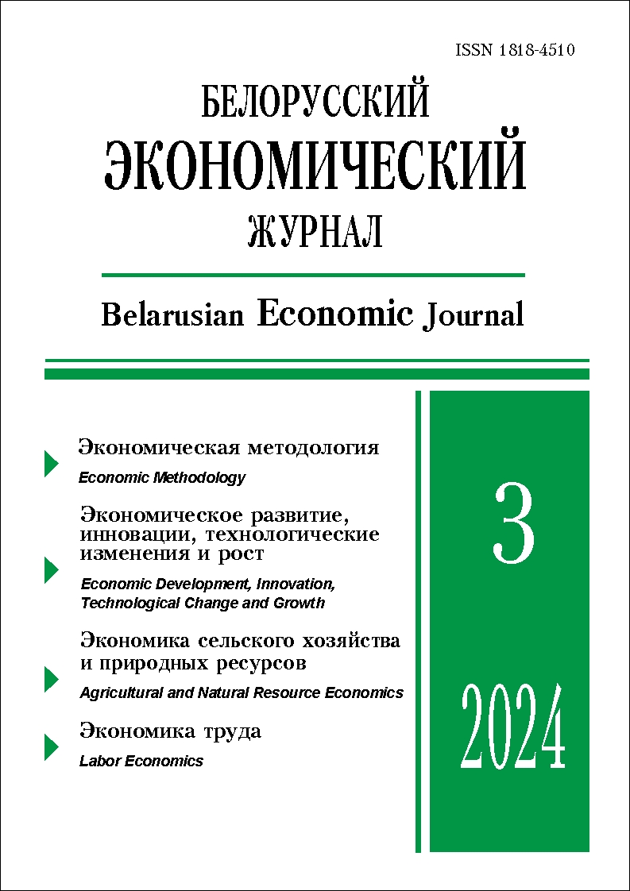 | ISSN 1818-4510  Belarusian  Economic Journal  Quarterly scientific and practical journal  Published since 1997  No 3 ● 2024
RESUME

ECONOMIC SECURITY IN THEORETICAL ECONOMICS: METHODOLOGICAL APPROACHES AND CONTENT SEARCH

Sergey Kristinevich¹ (https://orcid.org/0000-0002-8140-7106)
¹ Belarusian State Economic University (Minsk, Belarus).
Corresponding author: Sergey Kristinevich (sk.bseu@gmail.com).
ABSTRACT. The article considers methodological approaches to the study of economic security, and identifies the key theoretical constructs used to reflect the content of this concept. It is suggested that economic security can be assessed not only by a set of indicators describing its state, but also from the point of view of the dynamics of these indicators in a short period of time. The author suggests a new approach in research methodology, interpretation and methodological support for assessing economic security. Promising directions of research on the problem of economic security are substantiated.
KEYWORDS: economic security, scientific and technological security, information security, demographic security, economic growth.
JEL-code: A10, B41, O40.
DOI: 10.46782/1818-4510-2024-3-4-18
Received 18.04.2024
In citation: Kristinevich S. 2024. Economic security in theoretical economics: methodological approaches and content search. Belorusskiy ekonomicheskiy zhurnal. No 3. PP. 4–18. DOI: 10.46782/1818-4510-2024-3-4-18 (In Russ.)

COMMERCIALIZATION OF THE RESULTS OF SCIENTIFIC
AND SCIENTIFIC-TECHNICAL ACTIVITIES
IN THE ORGANIZATIONS OF THE REPUBLIC OF BELARUS
Lyudmila Nekhorosheva¹ (https://orcid.org/0000-0003-1242-9229),
Yury Nechepurenko²
¹ Belarusian State Economic University (Minsk, Belarus).
² Research Institute for Physical Chemical Problems of the Belarusian State University (Minsk, Belarus).
Corresponding author: Yury Nechepurenko (nuv_1956@mail.ru).
ABSTRACT. The article identifies the factors influencing the formation of an effective system for commercialization of the results of scientific and scientific-technical activities in order to increase the innovative potential, ensure technological sovereignty, and competitiveness of economic systems of various levels in the world and in the Republic of Belarus. The analysis and assessment of the effectiveness of commercialization of scientific and scientific-technical activities in organizations of the Ministry of Education have been carried out. Strategic directions for the development of innovative activities and infrastructure of the Ministry of Education of the Republic of Belarus for the period up to 2030 have been developed, including proposals for improving the legislation of the Republic of Belarus. A set of measures of a regulatory, methodological, and organizational nature has been proposed, aimed at increasing the effectiveness of commercialization of the results of scientific and scientific-technical activities and the effective implementation of the «University 4.0» model.
KEYWORDS: innovative activity, innovative infrastructure, commercialization of the results of scientific and scientific-technical activities, intellectual resources.
JEL-code: O30, O31, O32.
DOI: 10.46782/1818-4510-2024-3-19-34
Received 27.06.2024
In citation: Nekhorosheva L., Nechepurenko Y. 2024. Commercialization of the results of scientific and scientific- technical activities in the organizations of the republic of belarus. Belorusskiy ekonomicheskiy zhurnal. No 3. PP. 19–34. DOI: 10.46782/1818-4510-2024-3-19-34 (In Russ.)

DIGITAL TRANSFORMATION OF THE EAEU INDUSTRY
ON THE BASIS OF JOINT ECOSYSTEMS

Galina Goloventchik¹ (https://orcid.org/0000-0001-9074-1707)
¹ Belarusian State University (Minsk, Belarus).
Corresponding author: Galina Goloventchik (goloventchik@bsu.by).
ABSTRACT. The article discusses the EAEU policy on the digital transformation of industry. The factors hindering the development of the digital transformation of the EAEU industry have been identified. The author suggests creating a Eurasian industrial digital ecosystem based on cross-border digital platforms of industrial enterprises, and describes the basic architecture of such a platform.
Keywords: Eurasian digital ecosystem, digital platform.
JEL-code: L2, O14, O30.
DOI: 10.46782/1818-4510-2024-3-35-44
Received 20.06.2024
In citation: Goloventchik G. 2024. Digital transformation of the eaeu industry on the basis of joint ecosystems. Belorusskiy ekonomicheskiy zhurnal. No 3. PP. 35–44. DOI: 10.46782/1818-4510-2023-3-35-44 (In Russ.)

NATIONAL SUSTAINABLE DEVELOPMENT MODEL
OF SWEDEN: IMPERATIVES AND TRENDS OF DYNAMICS

Yury Mazurov¹ (https://orcid.org/0000-0001-9716-2783),
Nina Alekseeva¹ (https://orcid.org/0000-0002-5989-4139),
Alla Pakina¹ (https://orcid.org/0000-0003-2403-8399 )
¹ Lomonosov Moscow State University (Moscow, Russia).
Corresponding author: Yury Mazurov (jmazurov@yandex.ru).
ABSTRACT. The article examines conceptual ideas about sustainable development using Sweden as an example. The authors highlight the imperatives of the Swedish model of sustainable development as well as the forms and results of their manifestation. The characteristics of modern trends in the national development model are given.
KEYWORDS: sustainable development, development model, development imperatives, development trends, historical heritage, Sweden.
JEL-code: N54, Q56, O52.
DOI: 10.46782/1818-4510-2024-3-45-55
Received 6.08.2024
In citation: Mazurov Y., Alekseeva N., Pakina A. 2024. National sustainable development model of sweden: imperatives and trends of dynamics. Belorusskiy ekonomicheskiy zhurnal. No 3. PP. 45–55 DOI: 10.46782/1818-4510-2024-3-45-55 (In Russ.)

COMPREHENSIVE METHODOLOGY FOR ASSESSMENT
AND CLASSIFICATION OF AGRO-FOOD PRODUCTS
WITH HIGH Value ADDED

Andrey Pilipuk¹ (https://orcid.org/0000-0002-2770-939Х),
Svetlana Kondratenko¹ (https://orcid.org/0009-0003-9494-3914),
Nikolay Artyushevsky¹ (https://orcid.org/0000-0002-7115-7932)
¹ Institute of Systems Research in the Agro-Industrial Complex of the National Academy
of Sciences of Belarus (Minsk, Belarus).
Corresponding author: Svetlana Kondratenko (kondratenko-0703@mail.ru).
ABSTRACT. The article presents the results of the analysis of trends in the global food market in the context of competition factors and the formation of value chains for agro-food products. The key tasks in terms of strengthening the production and export potential of the national agro-industrial complex are identified. The authors have developed a methodology for identifying and classifying agro-food products that ensure the formation of higher value added at the enterprise level based on the use of private indicators. The article contains the necessary information and methodological tools for identifying effective practical approaches to increasing revenue and value added of agro-industrial enterprises by identifying and maximizing competitive advantages.
KEYWORDS: agro-industrial complex, production and export potential, products with high value added, innovative activity, competitiveness, strategy.
JEL-code: O13, Q13, Q18.
DOI: 10.46782/1818-4510-2024-3-56-70
Received 28.08.2024
In citation: Pilipuk A., Kondratenko S., Artyushevsky N. 2024. Comprehensive methodology for assessment and classification of agro-food products with high Value added. Belorusskiy ekonomicheskiy zhurnal. No 3. PP. 56–70. DOI: 10.46782/1818-4510-2024-3-56-70 (In Russ.)

TRANSFORMATION OF AGRICULTURAL ORGANIZATIONS PROCESSES USING DIGITAL MANAGEMENT TECHNOLOGIES

Paul Yukhniuk¹ (https://orcid.org/0000-0002-7181-3629)
¹ Academy of Public Administration under the President of the Republic of Belarus (Minsk, Belarus).
Corresponding author: Paul Yukhniuk (paul.yukhniuk@gmail.com).
ABSTRACT. The article outlines the features of digital transformation. The stages of digital transformation of production and management processes of agricultural organizations are highlighted. The author suggests an action plan for the implementation of advanced information and communication technologies for crop production organizations.
Keywords: digital maturity, digital transformation, digital technologies, Agile methodology, Lean management, business agility, roadmap, agriculture.
JEL-code: М54, O13, Q16.
DOI: 10.46782/1818-4510-2024-3-71-79
Received 16.04.2024
In citation: Yukhniuk P. 2024. Transformation of agricultural organizations processes using digital management technologies. Belorusskiy ekonomicheskiy zhurnal. No 3. PP. 71–79. DOI: 10.46782/1818-4510-2023-3-71-79 (In Russ.)

THE LABOUR MARKET OF THE REPUBLIC OF BELARUS: DEVELOPMENT IN THE CONTEXT OF MODERN CHALLENGES
Аlena Vankevich¹ (https://orcid.org/0000-0001-8064-8250),
Olga Zaytseva¹ (https://orcid.org/0000-0002-2801-7459)
¹ Vitebsk State Technological University (Vitebsk, Belarus).
Corresponding author: Alena Vankevich (vankevich_ev@tut.by).
ABSTRACT. The article presents the results of the analysis of trends in the development of the labour market of the Republic of Belarus in the modern conditions of digitalisation and globalisation. The authors found that the growth in the number of vacancies does not allow conclusions to be drawn about the growth in the demand for labour The authors also substantiate the existence of problems in measuring the main indicators of the Belarusian labour market, which are linked to the formation of information and analytical system of the labour market. It is concluded that it is necessary to shift the focus on the growth of labour productivity rather than on the employment rate. The authors suggest measures for the regulation of the labour market of the Republic of Belarus in the current and strategic perspective.
Keywords: labour market, digitalisation, labour supply, labour demand, skills.
JEL-code: E24, J21, J22, J23, J64.
DOI: 10.46782/1818-4510-2023-3-80-94
Received 10.09.2024
In citation: Vankevich A., Zaytseva о. 2024. The labour market of the republic of belarus: development in the context of modern challenges. Belorusskiy ekonomicheskiy zhurnal. No 3. PP. 80–94. DOI: 10.46782/1818-4510-2024-3-80-94 (In Russ.)

ON THE TRENDS OF INTERREGIONAL INEQUALITY
IN WAGES IN THE REPUBLIC OF BELARUS
Tatyana Makovetskaya¹ (https://orcid.org/0000-0001-7748-7484)
¹ Belarusian State University (Minsk, Belarus).
Corresponding author: Tatyana Makovetskaya (maktatsiana@gmail.com).
ABSTRACT. The article presents an assessment of trends characterizing interregional wage disparities in the Republic of Belarus for the period from 2015 to 2023. It examines structural changes in the extreme decile groups formed from basic-level administrative-territorial units and analyzes the dynamics of various differentiation coefficients. The paper provides a quantitative assessment of interregional wage differentiation. Additionally, a decomposition of the Theil index is conducted to determine the impact of interregional and intraregional inequality on the overall magnitude of disparities. The author makes a conclusion about weak positive dynamics indicating a reduction in disparities starting from 2022.
Keywords: wages, interregional inequality, differentiation, Theil index.
JEL-code: J31, R13, R58.
DOI: 10.46782/1818-4510-2024-3-95-107
Received 6.08.2024
In citation: Makovetskaya T. 2024. On the trends of interregional inequality in wages in the republic of belarus. Belorusskiy ekonomicheskiy zhurnal. No 3. PP. 95–107 DOI: 10.46782/1818-4510-2024-3-95-107 (In Russ.)

GENESIS OF FINANCIAL MARKETS IN THE CONTEXT
OF FORMATION OF THE MAIN SCIENTIFIC ECONOMIC SCHOOLS
AND THEORIES OF MONEY

Sergey Kabushkin¹ (https://orcid.org/0000-0002-8994-407X),
Maryna Nikonorova¹ (https://orcid.org/0000-0003-4509-9801)
¹ Belarusian State Economic University (Minsk, Belarus).
Corresponding author: Sergey Kabushkin (S.N.Kabushkin@yandex.ru).
ABSTRACT. The article considers the aspects of the creation and development of financial markets within the framework of the development of the main economic schools and theories of money in order to identify their interrelation and influence on modern processes of transformation in this area. The study of the genesis of financial markets is based on an interdisciplinary approach using a hierarchical sequence: socio-economic system, financial system, financial markets system. It is noted that financial markets are formed and function in the conditions of interaction of three main spheres of economic relations – monetary, credit and financial. Conclusions are formulated on development trends of modern national and international financial markets.
KEYWORDS: financial market system, financial system, forms of money, institutionalism, monetarism, systems theory, credit relations, money circulation, digital financial assets.
JEL-code: B10, G10, E40.
DOI: 10.46782/1818-4510-2024-3-108-122
Received 24.04.2024
In citation: Kabushkin .S., Nikonorova M. 2024. Genesis of financial markets in the context of formation of the main scientific economic schools and theories of money. Belorusskiy ekonomicheskiy zhurnal. No 3. PP. 108–122 DOI: 10.46782/1818-4510-2024-3-108-122 (In Russ.)

ORGANIZING LEASING ACTIVITIES AS A DRIVER OF ECONOMIC MODERNIZATION:
POSSIBILITIES OF USING CHINA’S EXPERIENCE FOR THE EAEU COUNTRIES
Vladimir Nikolaevsky¹ (https://orcid.org/0000-0003-2643-6657)
¹ Belarusian National Technical University (Minsk, Belarus).
Corresponding author: Vladimir Nikolaevsky (v.nikolaevsky@tut.by).
ABSTRACT. The article considers the experience of organizing leasing activities in China. The features and periods of its development are highlighted. The author assesses the indicators of leasing services development in 2010–2019 and suggests the directions for applying China’s experience in organizing leasing activities for the EAEU countries.

KEYWORDS: leasing, leasing activities, organizational investment mediation, free economic zones.
JEL-code: B59, D25, G28, G38.
DOI: 10.46782/1818-4510-2024-3-123-136
Received 1.07.2024
In citation: Nikolaevsky V. 2024. Organizing leasing activities as a driver of economic modernization: possibilities of using china’s experience for the eaeu countries. Belorusskiy ekonomicheskiy zhurnal. No 3. PP. 123–136. DOI: 10.46782/1818-4510-2024-3-123-136 (In Russ.)

GLOBAL VALUE CHAINS MANAGEMENT IN METALLURGY
AND METALWORKING

Oleg Navarro¹
PK Stalprokat (Moscow, Russia).
Corresponding author: Oleg Navarro (tabachnikova_eka@mail.ru).
ABSTRACT. The article considers the theoretical aspects of global value chain management and presents the examples of global value chain management models in various industries. The author analyses the transformation of management models in the metallurgical and metalworking industries. A conclusion is made on the applicability of management models for the sustainable development of industrial enterprises.
KEYWORDS: global value chains, metallurgy, metalworking, governance, networks, transaction costs, value chain modularity.
JEL-code: D23, F23, L22, L61
DOI: 10.46782/1818-4510-2024-3-137-149
Received 30.07.2024
In citation: Navarro O. 2024. Global value chains management in metallurgy and metalworking. Belorusskiy ekonomicheskiy zhurnal. No 3. PP. 137–149. DOI: 10.46782/1818-4510-2024-3-137-149 (In Russ.)

