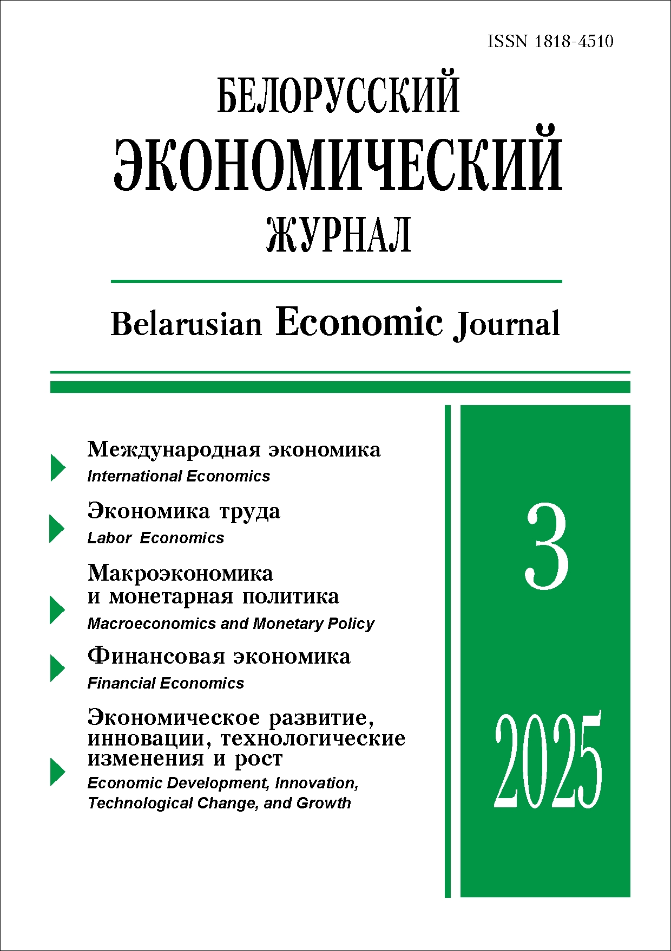 | ISSN 1818-4510  Belarusian  Economic Journal  Quarterly scientific and practical journal  Published since 1997  No 3 ● 2025
RESUME

TRADE AND ECONOMIC LIBERALIZATION IN THE COMPREHENSIVE REGIONAL ECONOMIC PARTNERSHIP: FEATURES, CONSEQUENCES, AND PROSPECTS FOR THE MEMBER STATES AND THE EURASIAN ECONOMIC UNION
Alla Pranevich¹ (https://orcid.org/0000-0003-2716-8201),
Alena Petrushkevich¹ (https://orcid.org/0000-0001-5962-0405),
Vera Ozhigina¹ (https://orcid.org/0000-0002-4661-9074)
Authors affiliation: ¹ Belarusian State Economic University (Minsk, Belarus).
Corresponding author: Alla Pranevich (pranevich@bseu.by).

ABSTRACT. The article shows the features of international integration in the Regional Comprehensive Economic Partnership (RCEP). The approaches to liberalization in the RCEP are considered, defining the opportunities and limitations in the markets of goods, services, digital data, intellectual property, and capital. To assess the economic effects of RCEP, we analyzed the dynamics of growth in the global share of the union in these markets, changes in extra-regional and intra-regional trade, and the consequences for participating countries. An assessment of trade and investment cooperation between the Regional Comprehensive Economic Partnership (RCEP) and the Eurasian Economic Union (EAEU) was carried out, with an emphasis on the trade structure of foreign trade in goods and services. It is shown that the EAEU has the potential to develop multi-faceted cooperation with the RCEP in the long term. This can occur along two main tracks: the EAEU-ASEAN and the EAEU-RCEP. The main stages, opportunities, and difficulties of their implementation are presented.
Keywords: international economic integration, trade, foreign direct investment, intellectual property rights, Regional Comprehensive Economic Partnership (RCEP), Eurasian Economic Union (EAEU).
JEL-code: F02, F53, O11, O19.
DOI: 10.46782/1818-4510-2025-3-4-22
Received 4.08.2025
In citation: Pranevich A., Petrushkevich A., Ozhigina V. 2025. trade and economic liberalization in the comprehensive regional economic partnership: features, consequences, and prospects for the member states and the eurasian economic union. belorusskiy ekonomicheskiy zhurnal. No 3. PP. 4–22. DOI: 10.46782/1818-4510-2025-3-4-22 (In Russ.)

transformation of international settlement models in the context of systemic and technological changes
Anna Levkovich¹ (https://orcid.org/0000-0002-7457-7414)
¹ Belarusian State Economic University (Minsk, Belarus).
Corresponding author: Anna Levkovich (anna.levkovich@mail.ru).
ABSTRACT. The article examines the transformation of the international settlement model in the context of systemic and technological changes. A general methodology for building payment systems is employed, including tools, institutions, technologies, and payment infrastructure. The main prerequisites for changing the architecture of cross-border settlements are identified, and alternatives to the traditional agency model of cross-border settlements are defined. The main limitations of emerging cross-border settlement models are revealed, and key trends in the transformation of cross-border settlements in the EAEU and the Republic of Belarus are identified. The article concludes that there is a trend in the global economy toward a multipolar system of international settlements based on the coexistence of payment systems utilizing a wide range of alternative and digital currencies, along with the EAEU economy's move toward creating an independent settlement system. Promising areas for the transformation of the cross-border payment system in the Republic of Belarus include maintaining the consistency of trade flows with its main trading partners, participating in the implementation of payment system projects being developed within the EAEU, and supporting cross-border payments while increasing the geographical diversification of the country's foreign trade.
Keywords: international settlements, economic sanctions, cross-border settlement model, correspondent relations, BRICS, cross-border settlements based on central banks' digital currencies.
JEL-code: F 39.
DOI: 10.46782/1818-4510-2025-3-23-37
Received 25.06.2025
In citation: Levkovich A. 2025. Transformation of international settlement models in the context of systemic and technological changes. belorusskiy ekonomicheskiy zhurnal. No 3. PP. 23–37. DOI: 10.46782/1818-4510-2025-3-23-37 (In Russ.)

Development of mutual trade of the republic of Belarus with the EAEU countries
Lyudmyla Bezpal’ko¹ (https://orcid.org/0000-0002-1184-2022)
¹ Belarusian State Economic University (Minsk, Belarus).
Corresponding author: Lyudmyla Bezpal’ko (bezpalko0@mail.ru).
ABSTRACT. The article studies mutual trade between the Republic of Belarus and the EAEU countries from 2019 to 2023. An assessment was made of the balance of foreign trade in goods and services between Belarus and the EAEU member states for 2020–2021. Based on «mirror» statistics, the author evaluated the balance of foreign trade relations between Belarus and Armenia, Kazakhstan, and Kyrgyzstan for 2022–2023 in mutual trade in goods. The main trends in mutual trade of the Republic of Belarus within the framework of its membership in the EAEU are identified.
KEYWORDS: Republic of Belarus, EAEU, mutual trade in goods and services, balance of foreign trade relations.
JEL-code: F15, F17, Р51.
DOI: 10.46782/1818-4510-2025-3-38-53
Received 30.04.2025
In citation: Bezpal’ko L. 2025. Development of mutual trade of the republic of belarus with the eaeu countries. Belorusskiy ekonomicheskiy zhurnal. No 3. PP. 38–53. DOI: 10.46782/1818-4510-2025-3-38-53 (In Russ.)

INCLUSIVE EMPLOYMENT IN BELARUS: FEATURES
OF FUNCTIONING AND EVALUATION
Nataliya Makovskaya¹ (https://orcid.org/0000-0003-2909-2925)
¹1 Mogilev State University by A. Kuleshov (Mogilev, Belarus).
Corresponding author: Nataliya Makovskaya (maknata@mail.ru).
ABSTRACT. The article presents the results of a scientific study on the functioning of inclusive employment in the national economy of Belarus. A methodological approach is outlined for studying the employment of workers with disabilities, which allows for the assessment of key parameters of their employment under the socio-economic conditions of the Republic of Belarus. Regional features of inclusive employment are also identified.
KEYWORDS: inclusive employment, workers with disabilities, wages, inclusive employment, inclusive workplace.
JEL-code: J16, J21, J31.
DOI: 10.46782/1818-4510-2025-3-54-68
Received 28.05.2025
In citation: Makovskaya N. 2025. inclusive employment in belarus: features of functioning and evaluation. Belorusskiy ekonomicheskiy zhurnal. No 3. PP. 54–68. DOI: 10.46782/1818-4510-2025-3-54-68 (In Russ.)

ONLINE DATA SOURCES ON THE LABOR MARKET: CLASSIFICATION, FEATURES, AND RANKING APPROACHES
Olga Zaitseva¹ (https://orcid.org/0000-0002-2801-7459)

¹ Vitebsk State Technological University (Vitebsk, Belarus).
Corresponding author: Olga Zaitseva (olgazaiitseva@gmail.com).

ABSTRACT. The classification of online job portals is presented, their characteristics are analyzed, and a ranking methodology based on the analytical hierarchy method is proposed. The study covers both state and non-state portals in the Republic of Belarus, evaluating them in terms of volume, completeness, and structure of information. The proposed methodology provides an objective assessment of the informativeness and usefulness of online sources, contributing to informed decision-making in the field of employment and human resources.
Keywords: labor market, online job portals, ranking, Analytic Hierarchy Process (AHP).
JEL-code: C81, J21, J22, J23, J64.
DOI: 10.46782/1818-4510-2025-3-69-82
Received 5.07.2025
In citation: Zaitseva O. 2025. online data sources on the labor market: classification, features, and ranking approaches. Belorusskiy ekonomicheskiy zhurnal. No 3. PP. 69–82. DOI: 10.46782/1818-4510-2025-3-69-82 (In Russ.)

MACRO FACTORS OF THE SOCIAL ENVIRONMENT:
INFLUENCE ON ECONOMIC CYCLES IN BELARUS
Larisa Ziankova¹ (https://orcid.org/0000-0002-1959-430X),
Natallya Krytskaya¹ (https://orcid.org/0009-0002-5487-1437)

¹ Belarusian State Economic University (Minsk, Belarus).
Corresponding author: Natallya Krytskaya (pinkcherty@gmail.com).
ABSTRACT. The article studies the main socio-psychological and demographic factors influencing cycles in the economy. The dynamics of several macroeconomic indicators (income, GDP, savings, consumer behavioral reactions, and natural population movement) are analyzed using the tools of STATISTICA 10. A list of socio-psychological anticipatory indicators of crises characteristic of Belarus is identified.
Keywords: economic cycle, socio-psychological, demographic factors, leading indicators.
JEL-code: А10, Е3.
DOI: 10.46782/1818-4510-2025-3-83-96
Received 1.08.2025
In citation: Ziankova L., Krytskaya N. 2025. macro factors of the social environment: influence on economic cycles in belarus. Belorusskiy ekonomicheskiy zhurnal. No 3. PP. 83–96. DOI: 10.46782/1818-4510-2025-3-83-96 (In Russ.)

Methodology for assessing the efficiency
of the mechanism of preferential lending
for the agro-industrial complex

DmitryKorobeynikov¹ (https://orcid.org/0000-0003-4499-1566)
¹ Volgograd State Agrarian University (Volgograd, Russia).
Corresponding author: Dmitry Korobeynikov (korobeinikov77@yandex.ru).

ABSTRACT. A methodology has been developed for the qualitative and quantitative assessment of the current mechanism for preferential lending to the agro-industrial complex in the Russian Federation. It has been shown that the standard methodology for assessing the effectiveness of preferential lending, based on the ratio of preferential loans to subsidies, does not provide a realistic evaluation of budget expenditures and the economic efficiency of the preferential lending mechanism. The author’s methodology is based on the capital-creating theory of credit and focuses on assessing the effectiveness of preferential lending in terms of the ultimate goals—stimulating industry development. As a criterion for effectiveness, it is proposed that there be a close correlation between the dynamics of subsidies, preferential loans, and agricultural production performance indicators, indicating the positive role of preferential lending in the agro-industrial complex’s economic development. The assessment will utilize both qualitative and quantitative indicators. The quantitative assessment of preferential lending effectiveness relies on a normative system of indicator values, which involves forming a reference dynamic for the functioning entity. Testing of the proposed methodology confirmed the positive impact of preferential bank lending on the agro-industrial complex’s economic dynamics, while the moderate correlation between industry performance parameters and preferential lending indicates budgetary constraints on the latter.

Keywords: preferential lending, economic growth, economic efficiency assessment.
JEL-code: C13, E51, G28, Q14.
DOI: 10.46782/1818-4510-2025-3-97-109
Received 25.05.2025
In citation: Korobeynikov D. 2025. methodology for assessing the efficiency of the mechanism of preferential lending for the agro-industrial complex. Belorusskiy ekonomicheskiy zhurnal. No 3. PP. 97–109. DOI: 10.46782/1818-4510-2025-3-97-109 (In Russ.)

The decline in the market value as a key element
of the asset’s total cost of ownership: a comparison
of electric and classic cars
Uladzimir Shabeka¹ (https://orcid.org/0009-0005-1294-3000)

¹ Belarusian National Technical University (Minsk, Belarus).
Corresponding author: Uladzimir Shabeka (u.shabeka@gmail.com).

ABSTRACT. The article provides the results of the research conducted in Belarus aimed at quantifying the Decline in Market Value (DMV) as a key element of an asset’s Total Cost of Ownership (TCO). Methodological recommendations have been developed for implementing managerial decisions during legally significant actions involving the assets of organizations, entrepreneurs, and households. These recommendations have been further tested. The characteristics of DMV have been obtained based on a comparison between C-class cars with electric engines and those with internal combustion engines.
KEYWORDS: innovation, technological change, adaptation, choice of technique (surface transportation), electric vehicles, total cost of ownership, decline in the market value due to ownership, organizations, individual entrepreneurs and private household’s assets management.
JEL-code: L90, O21, О33, R42.
DOI: 10.46782/1818-4510-2025-3-110-121
Received 28.05.2025
In citation: Shabeka U.L. 2025. The Decline in the Market Value as a Key Element of the Asset’s Total Cost of ownership: a comparison of electric and classic cars. belorusskiy ekonomicheskiy zhurnal. no 3. pp. 110–121. doi: 10.46782/1818-4510-2025-3-110-121 (In Russ.)

INTEGRATION OF ARTIFICIAL INTELLIGENCE
INTO HUMAN RESOURCES MANAGEMENT
IN THE AGRICULTURAL SECTOR
Ekaterina Abilova¹ (https://orcid.org/0000-0003-0186-1921)
¹ Chelyabinsk State University (Chelyabinsk, Russia).
Corresponding author: Ekaterina Abilova (ekaterina.abilova@mail.ru ).

ABSTRACT. This article examines the integration of artificial intelligence into human resource management in agricultural technology companies. Significant advantages of digital solutions are discussed, such as increased efficiency and transparency, along with key issues related to the reliability of decisions made using artificial intelligence in these specific agricultural enterprises. The process of forming a career trajectory within the educational environment is studied, taking into account the requirements of national personnel policy, digital trends in education, and the regional specifics of the labor market. A comprehensive model for planning and managing an employee's professional career in the agricultural sector, based on digital technologies and artificial intelligence, is proposed. Additionally, the components of the model for building a career trajectory for young specialists are elaborated upon.
KEYWORDS: career trajectory, agricultural sector, human capital, artificial intelligence.
JEL-code: O13, O18.
DOI: 10.46782/1818-4510-2025-3-122-132.
Received 14.08.2025
In citation: Abilova E. 2025. integration of artificial intelligence into human resources management in the agricultural sector. Belorusskiy ekonomicheskiy zhurnal. No 3. PP. 122–132. DOI: 10.46782/1818-4510-2025-3-122-132 (In Russ.)

Синергетический зеленый механизм
для Инициативы «Пояс и Путь» в рамках ESG

Лоу Юнь¹ (https://orcid.org/0009-0006-8382-5607)

¹ Казахский национальный университет имени аль-Фараби (г. Алматы, Казахстан).
Corresponding author: Лоу Юнь (louy@aliyun.com).
Аннотация. В статье рассматривается интеграция принципов экологической, социальной и управленческой ответственности (ESG) в инициативу «Пояс и путь» (BRI) с целью укрепления устойчивого развития. С момента своего создания в 2013 г. эта инициатива превратилась в важную глобальную платформу сотрудничества, соответствующую принципам ESG и способствующую высококачественному развитию. В исследовании выявлены такие проблемы, как экологические риски, неравномерное внедрение принципов социальной ответственности и несогласованность стандартов управления.
На основе успешных примеров, включая ирригационный проект Рагахакантха в Шри-Ланке и проект Ямал СПГ в России, в статье показывается, как принципы ESG могут преобразовать инфраструктурные проекты в успешные экосистемы, способствующие развитию местных сообществ.
В исследовании подчеркивается необходимость создания постоянного механизма интеграции ESG-стандартов и целей устойчивого развития (ЦУР), а также оптимизации управления, стабилизации зеленого финансирования и стимулирования инноваций. В статье представлены принципы, которые помогут участникам инициативы «Пояс и путь» достичь сбалансированного экономического роста, защиты окружающей среды и социальной инклюзивности, таким образом выступив в качестве катализаторов устойчивого международного сотрудничества и долгосрочного процветания.
Ключевые слова: ESG, инициатива «Пояс и Путь», глобальное управление, экономическое
развитие, устойчивость.
JEL-классификация: O19.
DOI: 10.46782/1818-4510-2025-3-133-141
Материал поступил 21.04.2025 г.
Для цитирования: Лоу Юнь. 2025. Синергетический зеленый механизм для инициативы «Пояс и Путь» в рамках ESG. Белорусский экономический журнал. № 3. С. 133–141. DOI: 10.46782/1818-4510-2025-3-133-141

MILK AND DAIRY PRODUCTS MARKET IN INDONESIA:
STATUS AND OPPORTUNITIES
Aliaksandr Yanchuk1 (https://orcid.org/0000-0002-4486-6709)
1 Belarusian State Economic University (Minsk, Belarus).
Corresponding author: Aliaksandr Yanchuk (sandro.janchuk@gmail.com).
ABSTRACT. The article presents the results of a study on the milk and dairy products market in Indonesia. The author analyses the state of this market and identify opportunities for Belarusian enterprises to enter it. The author highlights the characteristics of the Indonesian dairy industry and determines specific demand factors. An in-depth analysis of foreign trade in this sector has been conducted, revealing the main external suppliers and possible entry strategies for Belarusian companies. Special attention is given to the regulation of dairy product supplies to the domestic market. Conclusions are drawn regarding the potential advantages and threats of operating in Indonesia, considering government regulations. The article also offers recommendations for developing foreign economic relations. In particular, it suggests not only direct exports but also collaboration with local cooperatives to promote modern technologies
KEYWORDS: dairy industry, dairy market, Indonesia, foreign trade, regulation of dairy supply.
JEL-code: F14, F23, O53, Q13.
DOI: 10.46782/1818-4510-2025-2-137-151
Received 11.04.2025
In citation: Yanchuk A. 2025. Milk and Dairy Products Market in Indonesia: Status and Opportunities. Belorusskiy ekonomicheskiy zhurnal. No 2. PP. 137–151. DOI: 10.46782/1818-4510-2025-2-137-151 (In Russ.)

