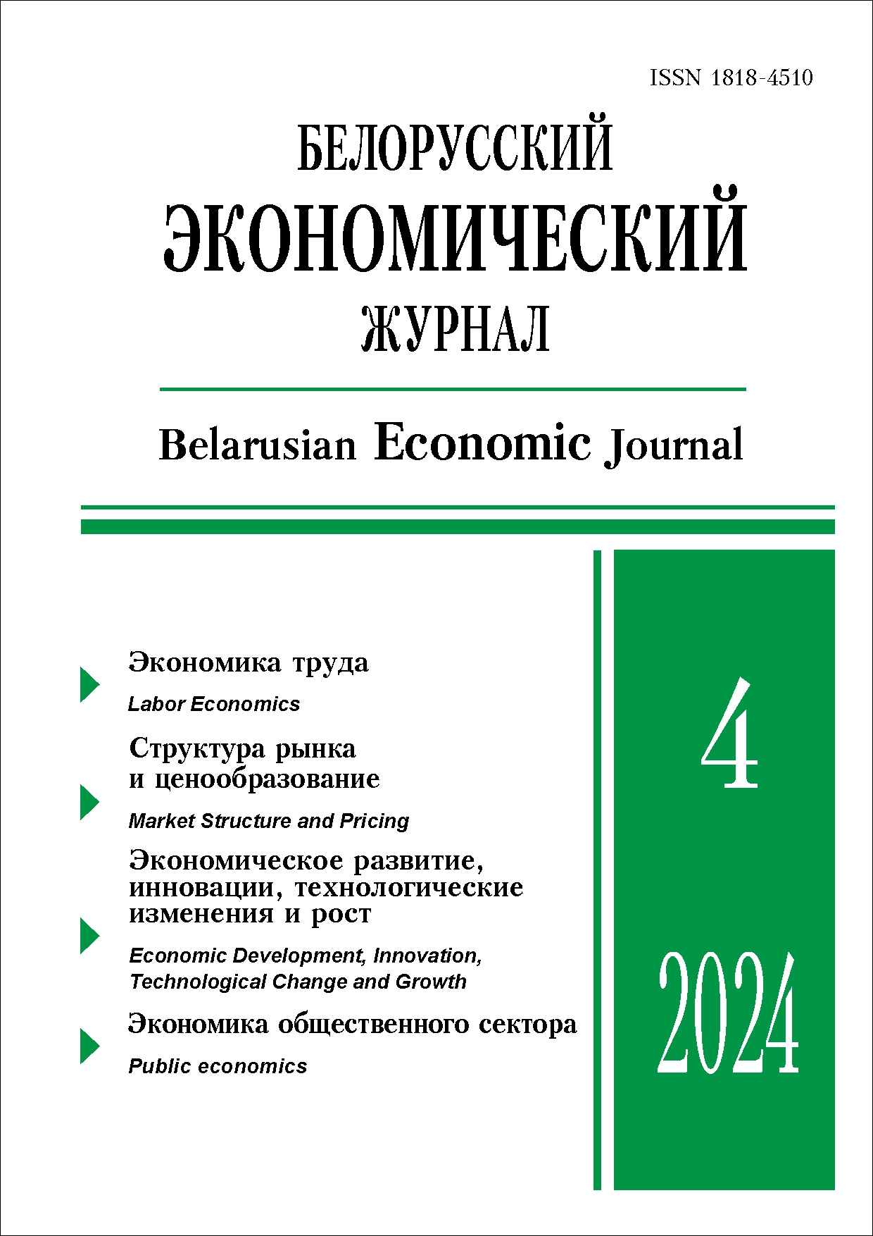 | ISSN 1818-4510  Belarusian  Economic Journal  Quarterly scientific and practical journal  Published since 1997  No 4 ● 2024
RESUME

WORKPLACES EFFECTIVENESS IN THE SALE OF PRODUCTS IN THE DOMESTIC AND SELECTED FOREIGN MARKETS
Alexander Gotovsky¹ (https://orcid.org/0000-0002-5470-9010),
Scopus Author ID: 57212407661,
Pavel Gutsol
¹ The Institute of Economics of the National Academy of Sciences of Belarus (Minsk, Belarus).
Corresponding author: Alexander Gotovsky (agotovsky@tut.by).
ABSTRACT. Having analysed the employment data, foreign trade statistics, and Input – Output tables, the authors determine the dependence of workplaces on the sale of various types of products to different sales markets. The article demonstrates the levels of efficiency of production chains by the amount of gross added value provided per job. The quantitative analysis provides an information basis for building an economic development strategy for the Republic of Belarus in the triad «sales markets - products - economic efficiency».
Keywords: gross domestic product, gross value added, jobs, sales markets, Input – Output tables, production and sales chains, structural decomposition analysis.
JEL-code: E24, E27, F41, F43, J24.
DOI: 0.46782/1818-4510-2024-4-4-21
Received 3.12.2024
In citation: Gotovsky A.V., Gutsol P.N. 2024. Workplaces effectiveness in the sale of products in the domestic and selected foreign markets. Belorusskiy ekonomicheskiy zhurnal. No 4. PP. 4–21. DOI: 10.46782/1818-4510-2024-4-4-21 (In Russ.)

WAGE NEGOTIATIONS: GENDER DIFFERENCES
AND WAYS TO OVERCOME THEM
Tatiana Maibarada¹ (https://orcid.org/0000-0002-9589-8620),
Kseniya Panich¹
¹ Belarusian State Economic University (Minsk, Belarus).
Corresponding author: Tatiana Maibarada (mtv_1@tut.by).
ABSTRACT. The article examines gender differences in wage bargaining. The results of two economic laboratory experiments that investigated gender differences and the effect of behavioural nudges on negotiation outcomes are compared. The authors come to conclusions about the existence of gender differences and make suggestions for designing behavioural interventions and possible directions for further research.
KEYWORDS: experimental economics, behavioral economics, gender, wages, labor market, nudges, experiment design.
JEL-code: C72, C90, C91, J16.
DOI: 10.46782/1818-4510-2024-4-22-33
Received 16.09.2024
In citation: Maibarada T., Panich K. 2024. Wage negotiations: gender differences and ways to overcome them. Belorusskiy ekonomicheskiy zhurnal. No 4. PP. 22–33. DOI: 10.46782/1818-4510-2024-4-22-33 (In Russ.)

DIGITAL ECOSYSTEMS: ESSENCE, CLASSIFICATION, STRUCTURE
Galina Goloventchik¹ (https://orcid.org/0000-0001-9074-1707)
¹ Belarusian State University (Minsk, Belarus).
Corresponding author: Galina Goloventchik (goloventchik@bsu.by).
ABSTRACT. Digital technologies, which have an increasing impact on the development of the modern economy, contribute to the formation of a fundamentally new type of economy – the digital economy, the main element of which is digital ecosystems. The article presents the essence of the concepts of «ecosystem» and «digital ecosystem». The key properties of digital ecosystems are formulated, and the value of the digital ecosystem for the company is determined. The classification of digital ecosystems according to several criteria is carried out, the structure of the digital ecosystem is presented, and examples of successful digital ecosystems are given.
Keywords: digital economy, digital ecosystems, digitalization.
JEL-code: L20, O14, O30.
DOI: 10.46782/1818-4510-2024-4-34-44
Received 20.06.2024

In citation: Goloventchik G. 2024. Digital ecosystems: essence, classification, structure. Belorusskiy ekonomicheskiy zhurnal. No 4. PP. 34–44. DOI: 10.46782/1818-4510-2024-4-34-44 (In Russ.)

ANALYSIS OF TECHNOLOGICAL SECURITY BASED ON THE METHODOLOGY OF INTER-INDUSTRY BALANCE
Valery Baynev¹ (https://orcid.org/0000-0001-9009-6752),
Mikalai Zianchuk¹ (https://orcid.org/0000-0003-4297-8501)
¹ Belarusian State University (Minsk, Belarus).
Corresponding author: Mikalai Zianchuk (zenchuknf@mail.ru).
ABSTRACT. The article introduces the improved methodology of V. Leontiev's inter-industry balance. It allows analyzing not only the cost characteristics of interactions between sectors of the national economy, but also the technological quality of these interactions. The authors demonstrate that the system of input-output tables modified in this way can be used to analyze the technological safety of socio-economic systems.
KEYWORDS: inter-industry balance, input-output tables, type of economic activity, technological intensity, technological quality, technological safety.
JEL-code: O13, O21, O33, B41, Q55.
DOI: 10.46782/1818-4510-2024-4-45-55
Received 5.12.2024
In citation: Baynev V., Zianchuk M. 2024. Analysis of technological security based on the methodology of inter-industry balance. Belorusskiy ekonomicheskiy zhurnal. No 4. PP. 45–55. DOI: 10.46782/1818-4510-2024-4-45-55 (In Russ.)

TARIFF POLICY IN THE ELECTRIC POWER INDUSTRY
OF THE REPUBLIC OF BELARUS: STATUS AND DIRECTIONS FOR IMPROVEMENT
Tatsiana Zoryna¹ (https://orcid.org/0000-0001-9665-2756),
Olga Yurkevich²
¹ Institute of Energy of the National Academy of Sciences (Minsk, Belarus),
²2 RUE «Vitebskenergo» (Vitebsk, Belarus).
Corresponding author: Olga Yurkevich (oi.yurkevich@yandex.by).
ABSTRACT. The article researches theoretical and practical aspects of tariff policy formation in the electric power industry of the Republic of Belarus. Based on the analysis of international experience of tariff regulation and the peculiarities of functioning of the Belarusian energy system, the main directions of improving the tariff policy in the electric power industry of the Republic of Belarus are defined. A methodology for assessing the impact of tariff policy on the competitiveness of industrial enterprises is proposed. Recommendations on expanding tariff differentiation with regard to the possibilities of digital transformation have been developed. The necessity of supplementing the system of energy security indicators with indicators characterizing the availability of fuel and energy resources for consumers is substantiated.
KEYWORDS: electricity tariffs, tariff policy, electric power industry, energy security, cross-subsidization, tariff differentiation.
JEL-code: D49, E64.
DOI: 10.46782/1818-4510-2024-4-56-72
Received 30.10.2024
In citation: Zoryna T., Yurkevich O. 2024. Tariff policy in the electric power industry of the republic of belarus: status and directions for improvement. Belorusskiy ekonomicheskiy zhurnal. No 4. PP. 56–72. DOI: 10.46782/1818-4510-2024-4-56-72 (In Russ.)

Tax aspects of commercialization
of intellectual property objects
in the concept of transfer pricing
Irina Loukianova¹
¹ Belarusian State Economic University (Minsk, Belarus).
Corresponding author: Irina Loukianova (i.loukianova@taxprof.by).
ABSTRACT. The study explores the challenges of using intellectual property for aggressive tax planning and the resulting transfer pricing rules imposed by tax authorities. It analyzes research on transfer pricing measures aimed at preventing tax burden reduction through intangible assets, a common method of tax avoidance in high-tax jurisdictions. The paper evaluates the impact of intangible assets on the global economy, reviews OECD Transfer Pricing Guidelines, including the DEMPE approach, and assesses Belarusian legislation regarding transaction pricing for property rights. Ultimately, it aims to develop optimal strategies for tax system reform while addressing potential imbalances and economic stability concerns.
Keywords: tax competition, unfair tax competition, fiscal policy, tax reform, transfer pricing; intellectual property, intangible assets, transnational corporations; industrial property rights, trademarks.
JEL-code: H21, H25, H26, O34.
DOI: 10.46782/1818-4510-2024-4-73-82
Received 24.12.2024
In citation: Loukianova I. 2024. Tax aspects of commercialization of intellectual property objects in the concept of transfer pricing. Belorusskiy ekonomicheskiy zhurnal. No 4. PP. 73–82 DOI: 10.46782/1818-4510-2024-4-73-82 (In Russ.)

PUBLIC GOODS: THEORETICAL FRAMEWORK
AND FINANCING IN THE REPUBLIC OF BELARUS
Andrey Filiptsou¹ (https: //orcid.org/0000-0002-4845-682X)
¹ Belarusian State Economic University (Minsk, Belarus).
Corresponding author: Andrey Filiptsou (filipsov@mail.ru).
ABSTRACT. The theoretical basis for the allocation of public and socially significant (merit) goods has been studied. A classification of goods is proposed according to the following criteria: completeness of manifestation of the properties of non-selectivity and non-excludability; satisfaction of needs; territorial; sources of financing; production method. The possibility of providing the country with public goods at the expense of the public and private sectors is analyzed. The influence of economic digitalization processes on the problem of providing the country with public goods has been identified. The expenses of the state budget of the Republic of Belarus for financing public and socially significant benefits, including the consolidated, republican and local budgets, are analyzed. It is proposed to include the following as expenditures on public goods: national activities; national defense; judiciary, law enforcement and security; environmental protection. It is proposed to include the following as expenditures on merit goods: the national economy; housing and communal services and housing construction; healthcare; physical education, sports, culture and media; education; social policy.
KEYWORDS: public good, socially significant goods, mixed goods, merit goods, public welfare, Republic of Belarus.
JEL-code: H41.
DOI: 10.46782/1818-4510-2024-4-83-95
Материал поступил 27.08.2024 г.
In citation: Filiptsou A. 2024. Public goods: theoretical framework and financing in the republic of belarus. Belorusskiy ekonomicheskiy zhurnal. No 4. PP. 83–95. DOI: 10.46782/1818-4510-2024-4-83-95

METHODOLOGICAL SUPPORT FOR ASSESSING
THE DEVELOPMENT OF A CIRCULAR ECONOMY
AT THE LEVEL OF A BUSINESS ENTITY
Anastasia Stanovskaya¹ (https://orcid.org/0000-0001-9340-2014)
¹ Belarusian State Economic Universit (Minsk, Belarus).
Corresponding author: Anastasia Stanovskaya (anastan01@yandex.ru).
ABSTRACT. The relevance of the transition to a closed-loop (circular) economy in the context of increasing environmental challenges and threats to sustainable development is substantiated. A methodological toolkit for assessing the development of a circular economy at the micro level has been developed, including methods for determining the index of an organization’s (enterprise’s) readiness for circular transformation and the integral index of the level of development of a circular economy. The author’s developments for assessing a circular economy in a number of mechanical engineering organizations are tested. Approaches for improving the development of a circular economy in mechanical engineering are proposed.
Keywords: circular economy, circular business models, resource efficiency, environmental impact.
JEL-code: L62, Q51, Q53, Q57.
DOI: 10.46782/1818-4510-2024-4-96-109
Received 11.11.2024

In citation: Stanovskaya A. 2024. Methodological support for assessing the development of a circular economy at the level of a business entity. Belorusskiy ekonomicheskiy zhurnal. No 4. PP. 96–109. DOI: 10.46782/1818-4510-2024-4-96-109 (In Russ.)

Meso-level subsystems of international economic integration
Vera Ozhigina¹ (https://orcid.org/0000-0002-4661-9074)
¹ Belarusian State Economic University (Minsk, Belarus).
Corresponding author: Vera Ozhigina (vera@ozhigina.com).
ABSTRACT. The study aims to define and classify mesosystems emerging from international economic integration and to explain their roles in integration design and policy. It examines various meso-level integration subsystems, such as corporations, public organizations, clusters, and special economic zones. By synthesizing temporal and spatial factors, the author proposes a classification of mesosystems formed during national economies' integration. This classification distinguishes the goals and objects of micro- and meso-economic policies and highlights the significance of mesosystems in integrating national economies into the global economy. The study emphasizes the importance of integration policy at the meso-level in science, technology, and healthcare.
Keywords: international economic integration, integration policy, integration design, mesosystem, mesoeconomics..
JEL-code: F15, L14, L2, L3.
DOI: 10.46782/1818-4510-2024-4-110-128
Received 2.12.2024
In citation: Ozhigina V. 2024. Meso-level subsystems of international economic integration. Belorusskiy ekonomicheskiy zhurnal. No 4. PP. 110–128. DOI: 10.46782/1818-4510-2024-4-110-128 (In Russ.)

Влияние либерализации торговли
на капитал здоровья: Обзор
Чжан Юйтин¹
¹ Белорусский государственный университет (г. Минск, Беларусь).
Аннотация. Рассматривается связь между либерализацией торговли и капиталом здоровья в контексте экономической глобализации. Учитывая ограниченную интеграцию теории торговли и экономики здоровья, проанализированы исследования о влиянии торговли на капитал здоровья. Разработана модель, основанная на производственной функции спроса на здоровье Гроссмана, для изучения косвенных эффектов с учетом динамики рынка труда, распределения доходов, загрязнения окружающей среды и государственных услуг. При анализе существующей литературы по данной тематике выделены достижения и недостатки, предложены направления для будущих исследований, в том числе с акцентом на данные из Китая.
Ключевые слова: либерализация торговли, капитал здоровья, производственная функция здоровья, детерминанты капитала здоровья.
JEL-классификация: F18, I15.
DOI: 10.46782/1818-4510-2024-4-129-143
Материал поступил 30.10.2024 г.
Для цитирования: Zhang Y.T. 2024. The Impact of Trade Liberalisation on Health Capital: A Review. Белорусский экономический журнал. № 4. С. 129–143. DOI: 10.46782/1818-4510-2024-4-129-143

